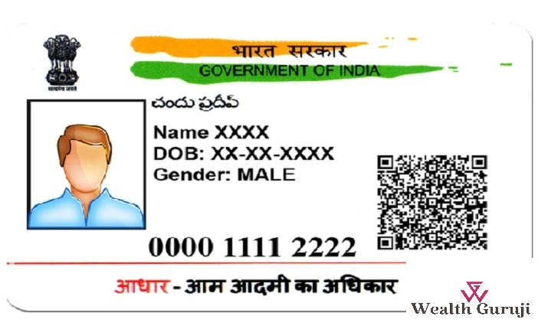





Name Shweta

DOB 29/08 2008

Address Saini mohalla bijwasan

1234 5678 9012 3456